Name___Kush Patel___________ Date:________________________________________

|  |  |  |
| --- | --- | --- |
|  | **Worksheet - “IP Addresses and DNS”** |  |

**Overview** 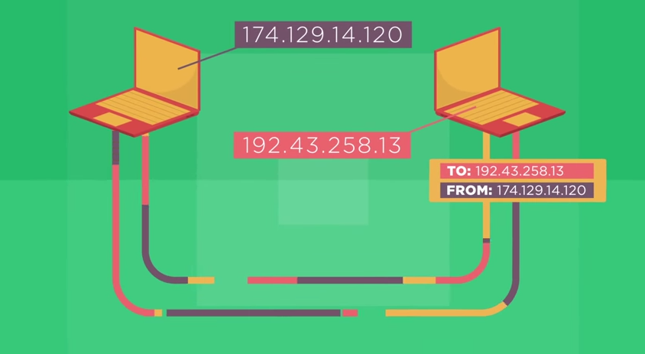

This video features the father of the Internet, Vint Cerf, and Microsoft engineer, Paolo Mejia, addressing the question, “How does data know where to go on the Internet?” They introduce the concepts of Internet Protocol (IP) addresses and the Domain Name System (DNS). In this worksheet, you will use ideas covered in the video as well as search for information on the Internet to answer questions… about the Internet!

**Directions**

1. Watch the video, “IP Addresses and DNS.”
2. Research any additional information required using an Internet search engine.

**Questions**

1. What is a protocol?

A set of rules that must be followed when transmitting data between electronic devices.

1. What is an Internet Protocol (IP) address? How is it organized hierarchically?

A unique string of numbers that identifies each computer using the internet protocol to communicate over a network.

8 bits = 1 byte, ipv4 contains 32 btis and our IP adress is broken down to 4 bytes (8 bits each) in a hierarchy.

The hierarchy goes as follows: first byte contains country/network, second byte is region/network, third byte is subnetwork, and fourth byte is device.

1. How many bits are in an IPv4 address? How many IPv4 addresses does that mean there are?

There are 32 bits in an Ipv4 address, this means that there 4,294,967,296 ipv4 addresses

1. What is the difference between IPv6 and IPv4. Why do we need IPv6?

Ipv4 is 32 bit and the number of the addresses available are quite low, ipv6 is 128 bit and therefore has a lot of adresses, we will probably never run out any time soon. We need ipv6 because of the plenty full of ip addresses that are still available to distribute.

1. What is an IP packet?

An IP packet is a packet of data that is carried over a IP network.

1. What is the difference between an IP address and an IP Packet?

IP address is a string of numbers that identify an IP network, IP packets are packets of data carried over the IP networks.

1. What is the purpose of the Domain Name System (DNS)?

Domain Name Servers are the Internet's equivalent of a phone book. They maintain a directory of domain names and translate them to Internet Protocol addresses.

1. Optional: What is the IP address of the computer you’re sitting at right now?

|  |  |  |  |  |
| --- | --- | --- | --- | --- |
| **Categories** | **Level 1** | **Level 2** | **Level 3** | **Level 4** |
| **Knowledge/Understanding/Communication and organization** | | | | |
| **Explanation of Answers,** **Use of proper grammar and**  **Presentation of information** | Few Questions are answered and writing is hard to understand.  >2 grammar mistakes  Information organization is poor. | Some Questions are answered and writing is hard to interpret.  <3 grammar mistakes  Information is somewhat organized. | Most questions are answered with some clarity.  Minor grammar mistakes and  organization is good. | All questions are answered with high degree of clarity.  Excellent grammar.  Information organization is excellent |
| Associated Activities of Week 2 | | | | |
| **Completion of KWL chart , Internet is for everyone and Research of DNS and Ddos in real world** | No to Few parts are completed of these activities. | | Some to all parts are completed with high degree of quality. | |

**Rubric for IP Address and DNS**